**Microsoft ADC Cybersecurity Skilling Program**

**WEEK ONE ASSIGNMENT**

**Student Name:** **Ashley Wenwa**

**INTRODUCTION**

This week I worked on alab that explores the capabilities of Microsoft Identity and AccessManagementSolutions**.** The modules in the labs I worked on were as follows:

* Explore Microsoft Entra ID User Settings.
* Microsoft Entra self-service password reset.
* Microsoft Entra Conditional Access.
* Explore Privileged Identity Management.

**TASKS COMPLETED**

1. **EXPLORE MICROSOFT ENTRA ID USER SETTINGS.**

I got to enable the audit log and the monitoring capabilities in Microsoft 365. I then proceeded to create a user “Sara Perez” whose profile I subsequently used to work on module two of the labs.

Here are some screenshots to better explain my process:

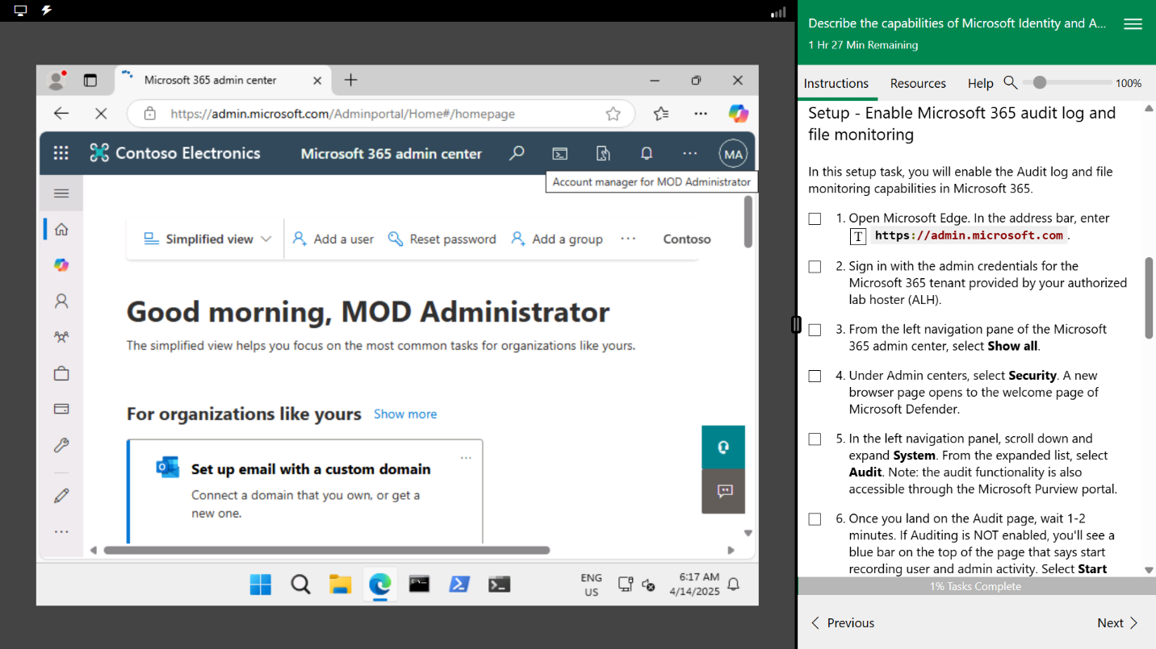

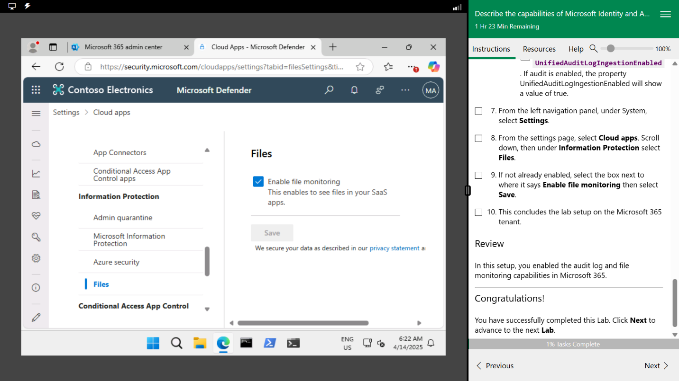

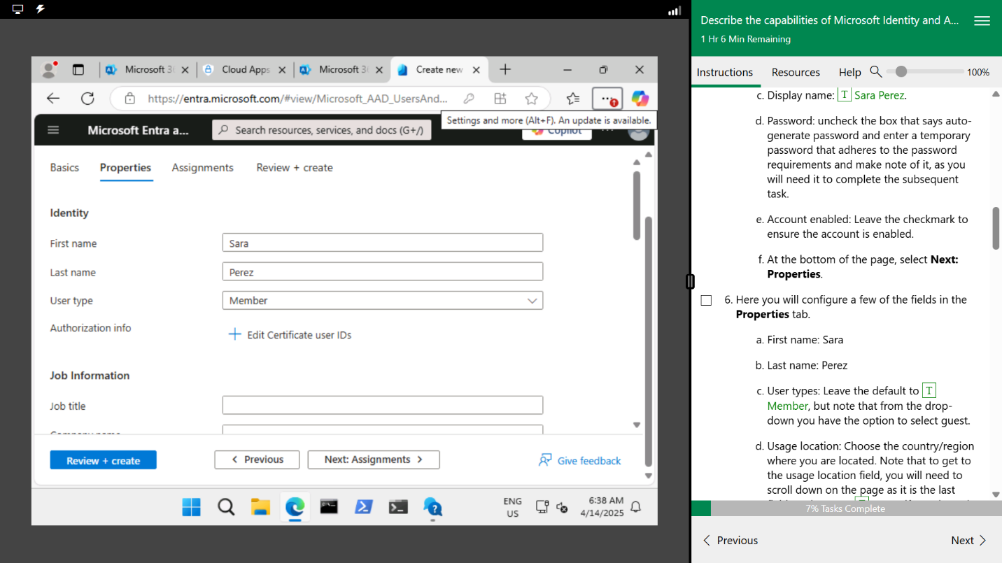

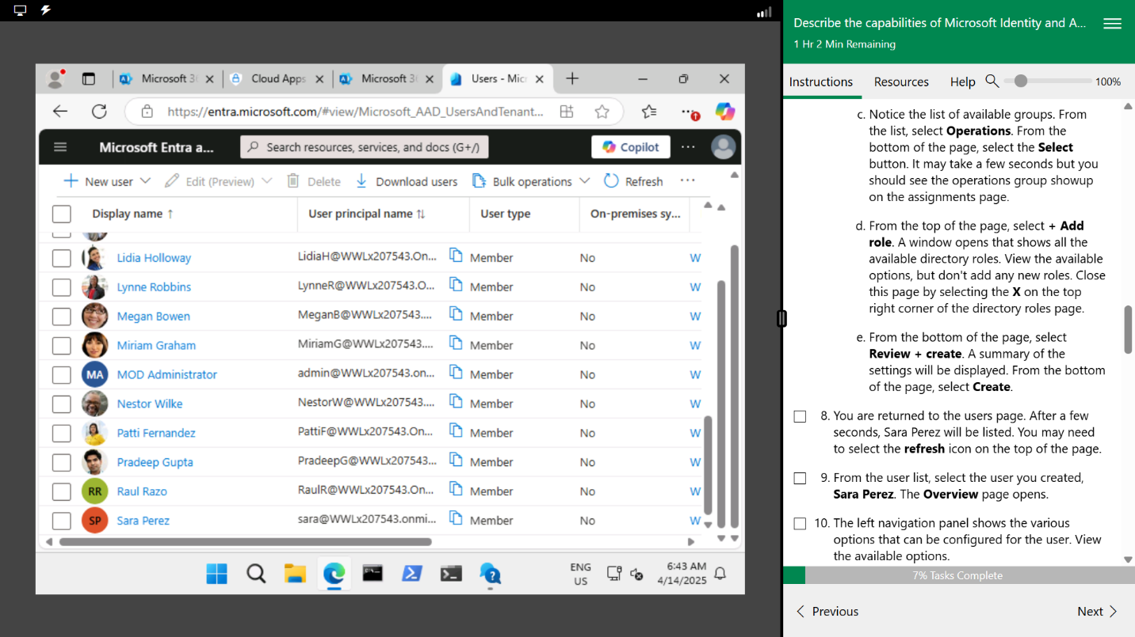

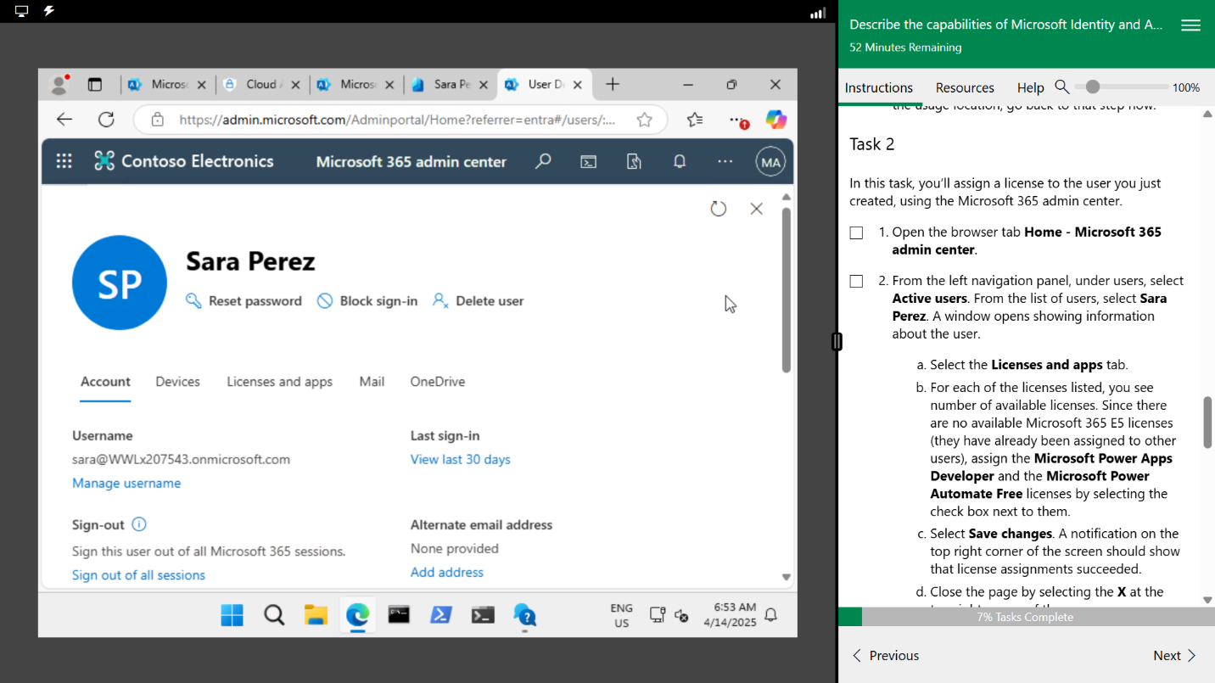

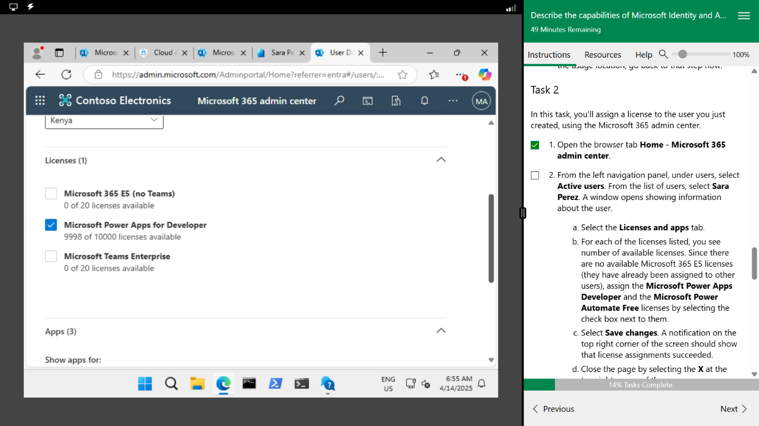

1. **MICROSOFT ENTRA SELF-SERVICE PASSWORD RESET.**

In this module I used a profile that I had already established from module one: “Sara Perez”. I proceeded to log in but instead I selected the “forgot password” option in order to show the self-service password reset capability.

Here are some screenshots to showcase my process:

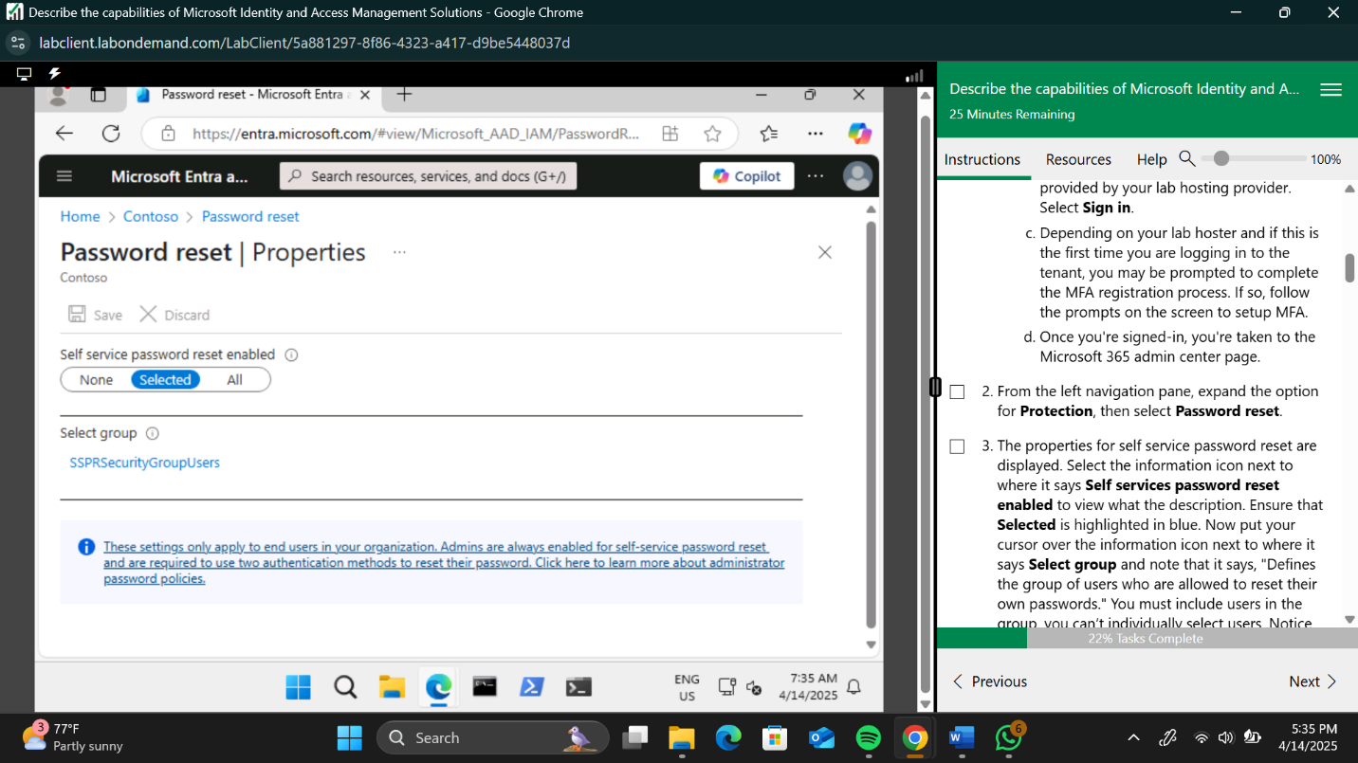

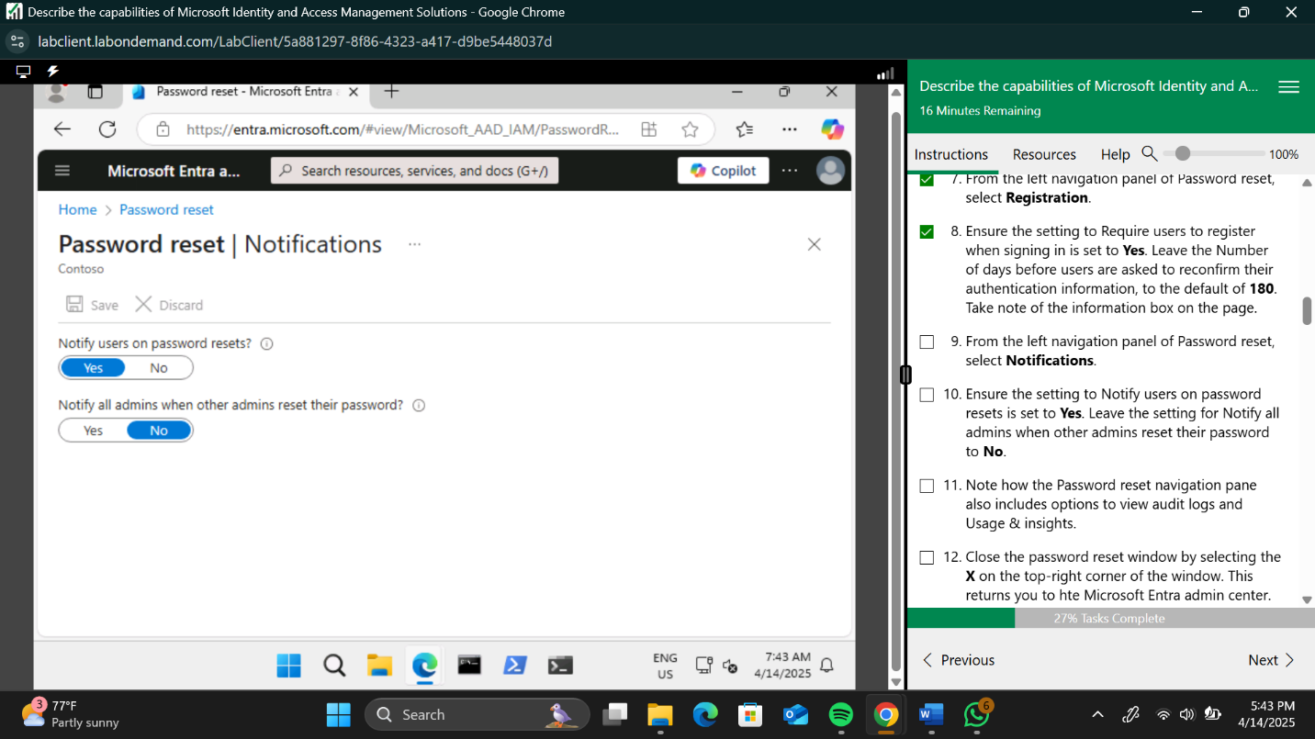

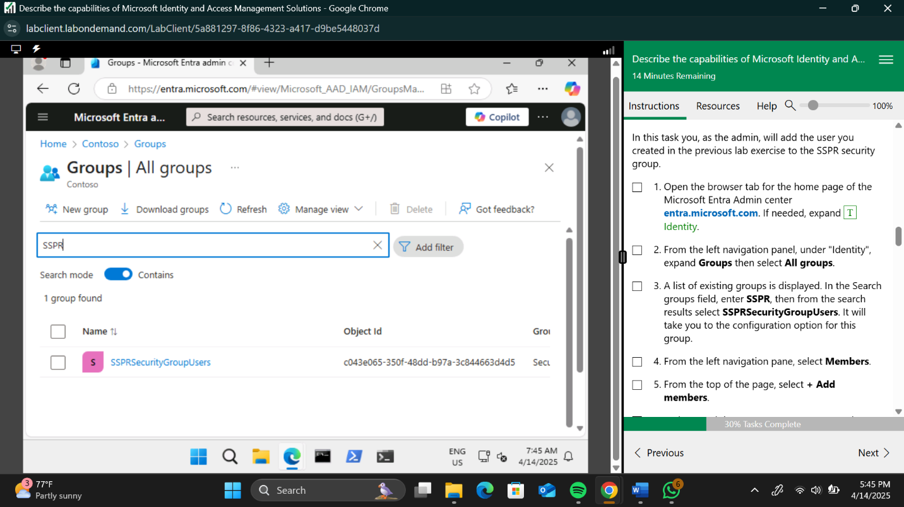

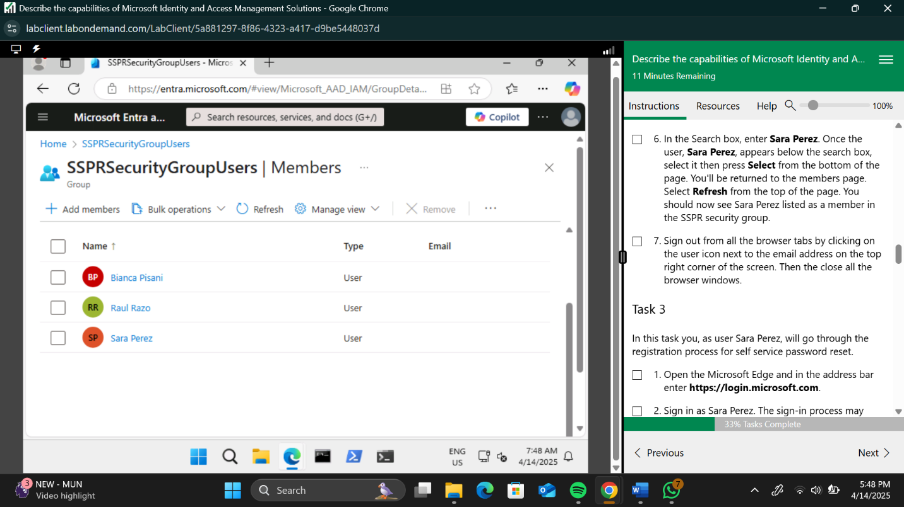

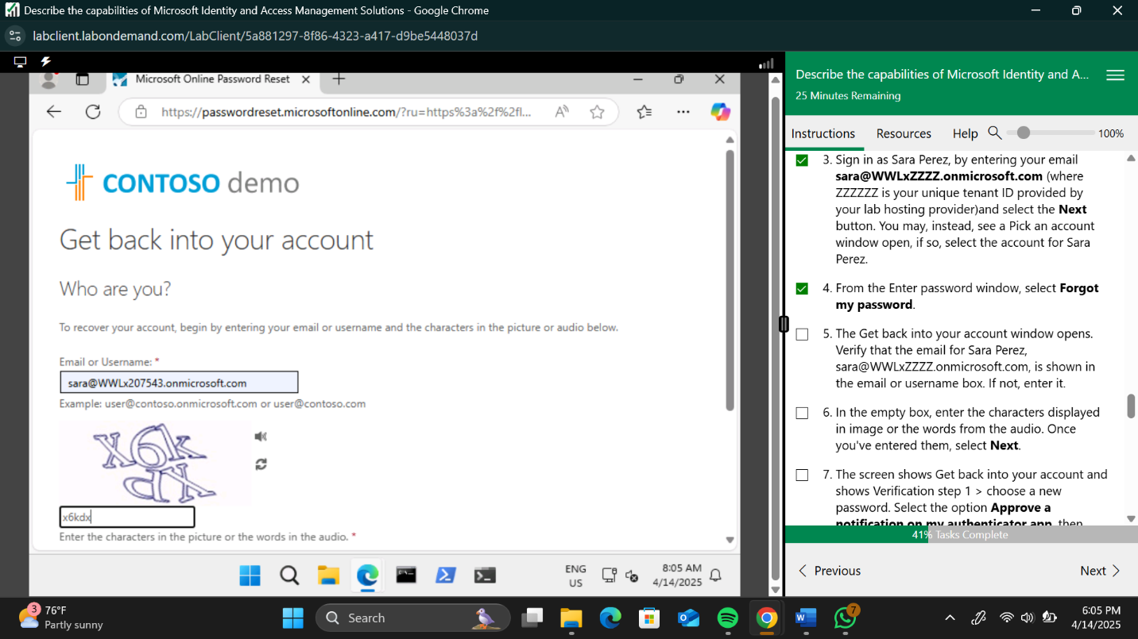

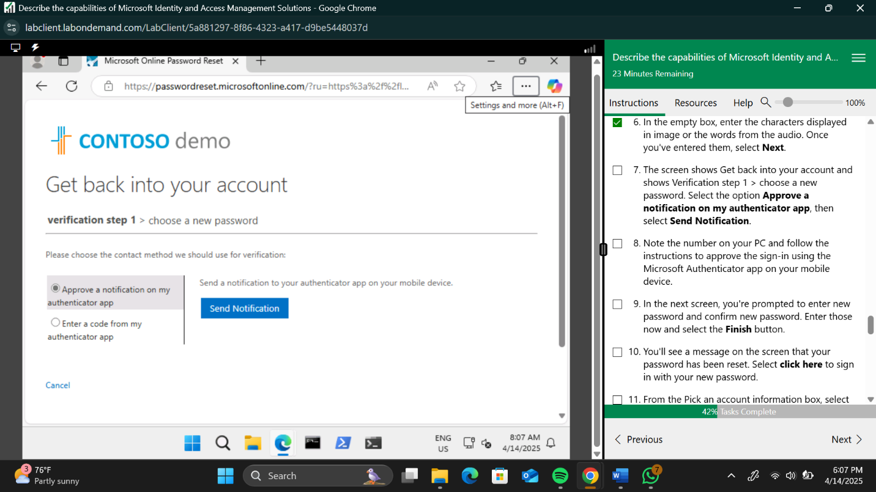

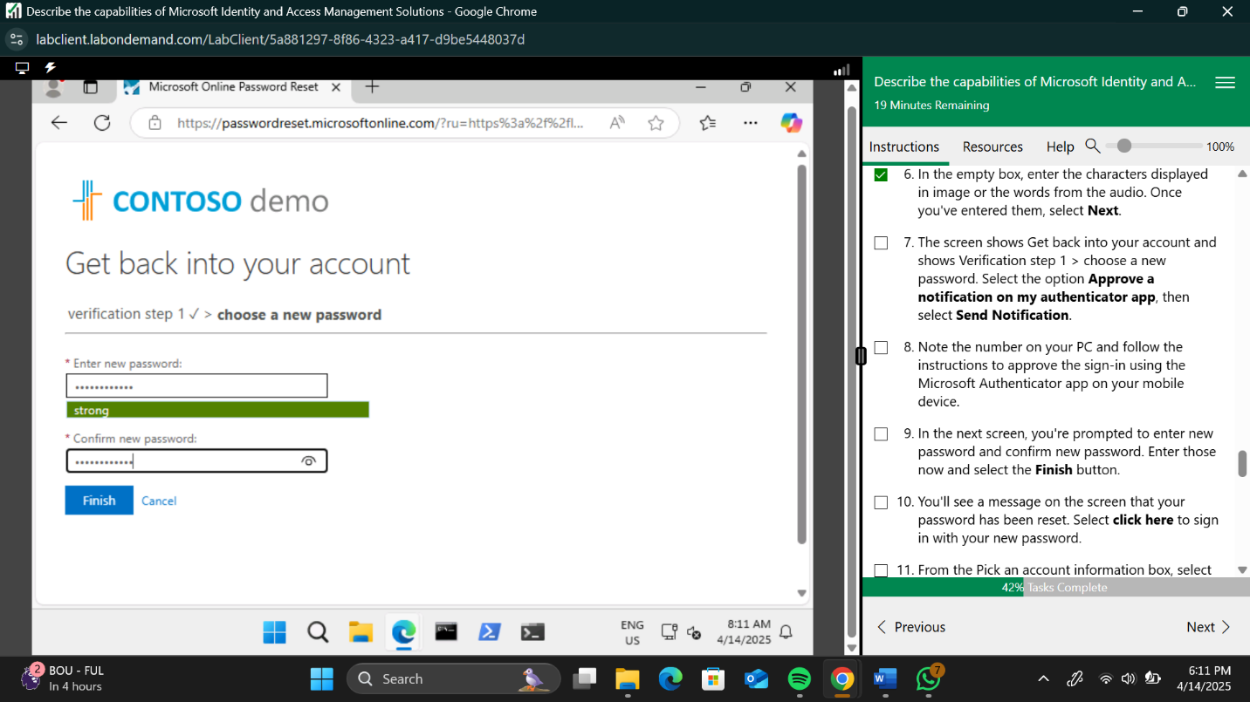

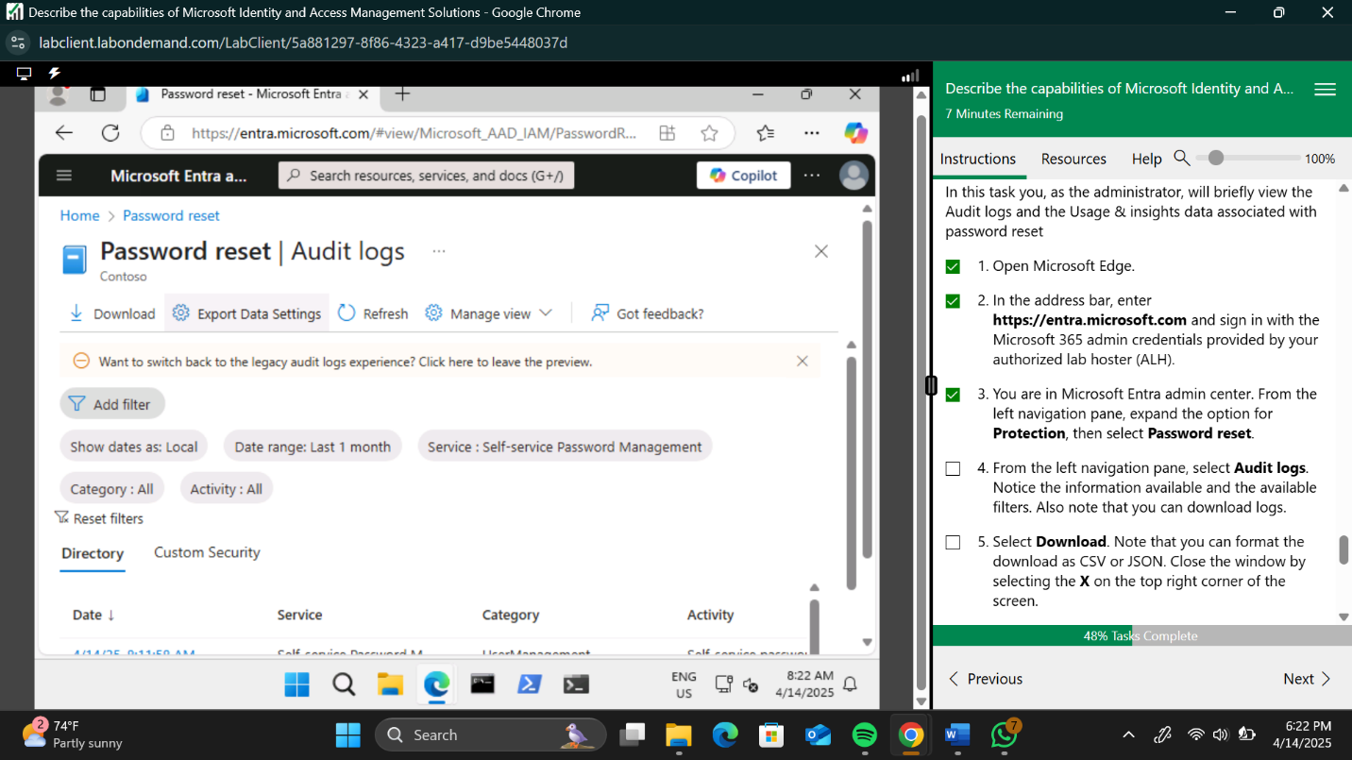

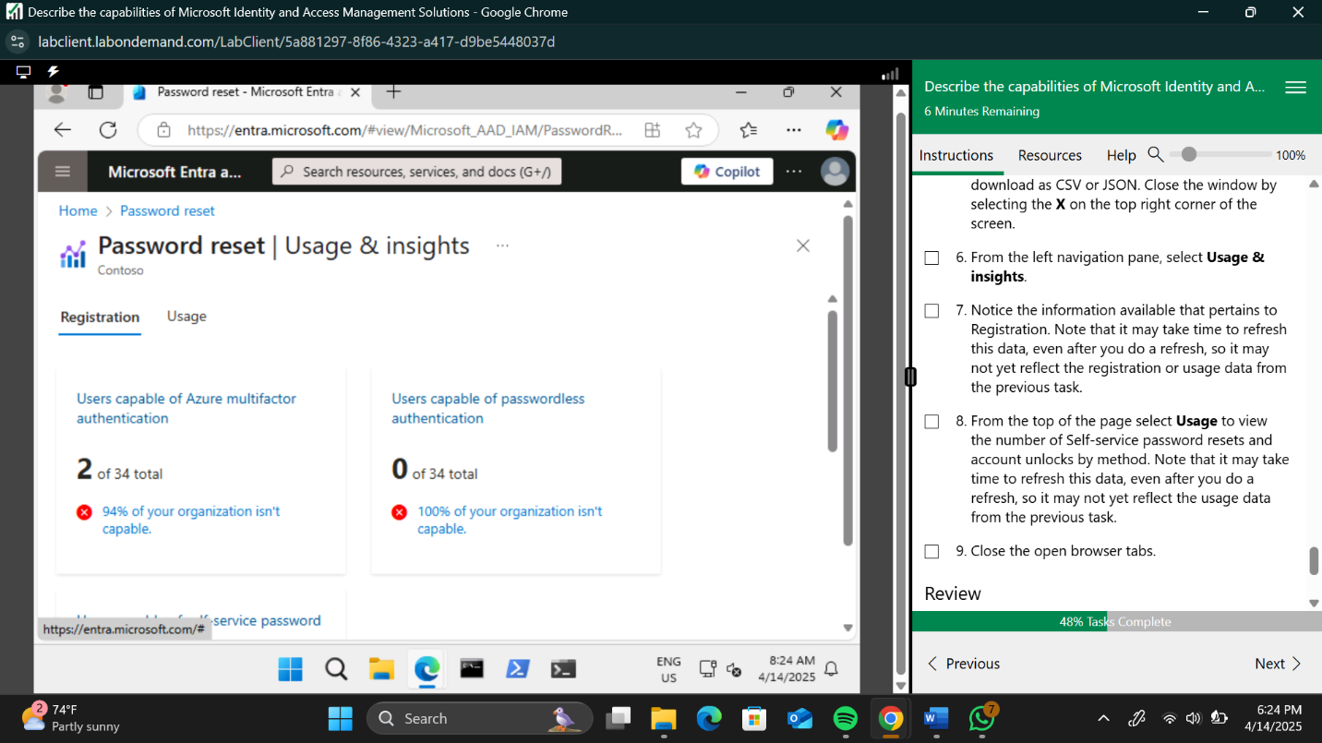

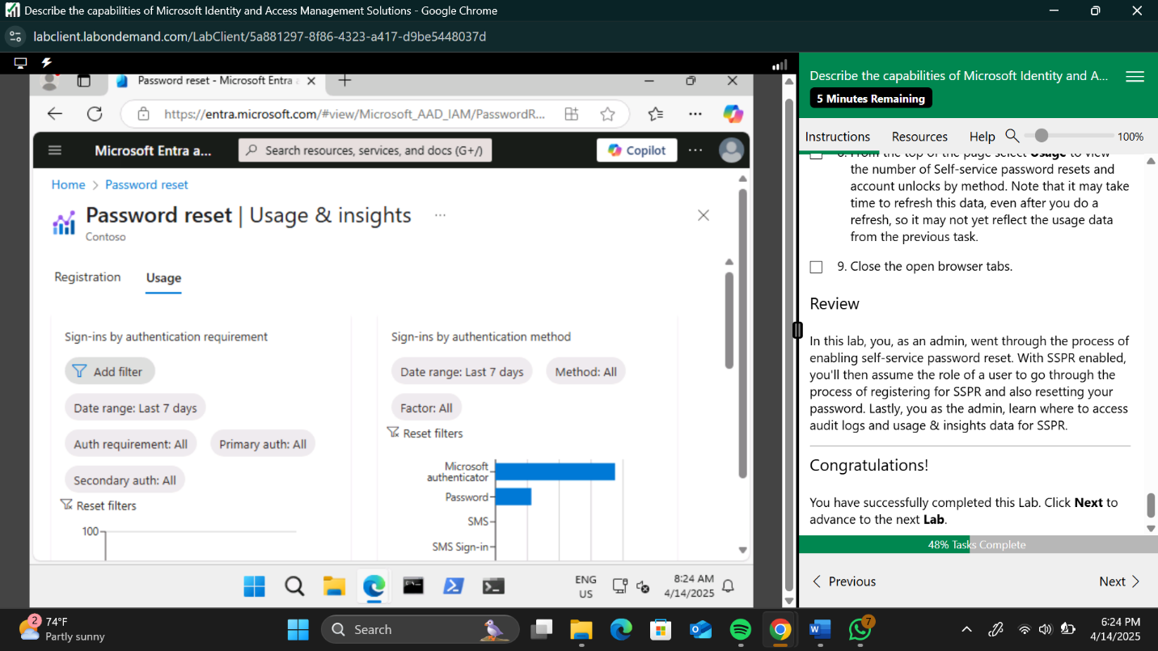

1. **MICROSOFT ENTRA CONDITIONAL ACCESS.**

In this module I used a profile titled “Debra Berger”. I signed in to her profile by resetting the password considering it was a new profile. I assigned conditional access to the account by following given instructions. This module was the challenging one for me since I had to try multiple times to get the desired result.

Here are some screenshots to show my process:

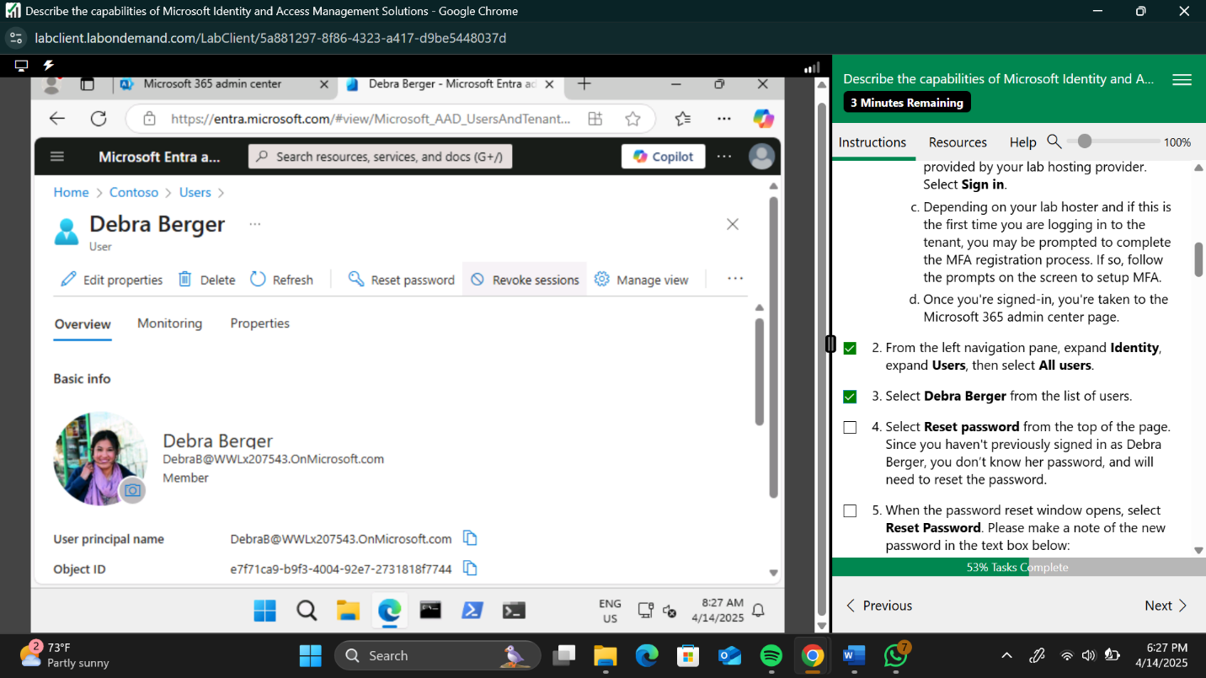

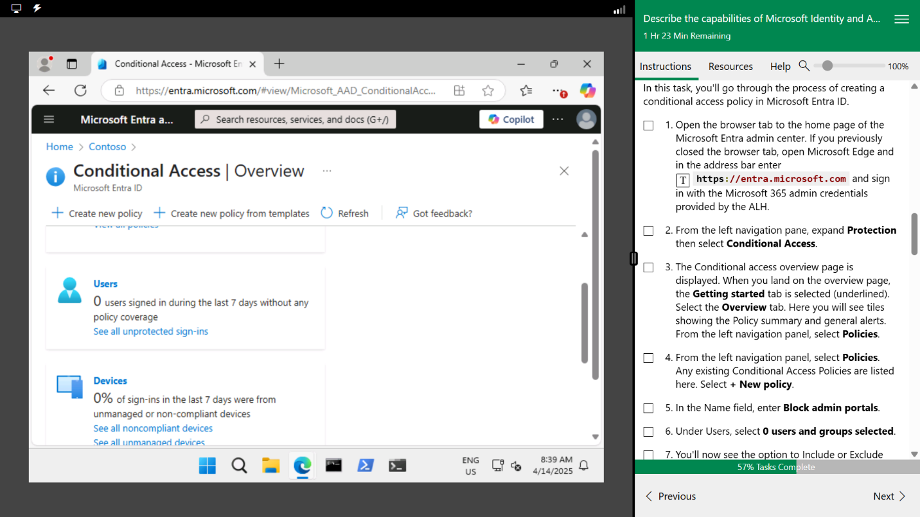

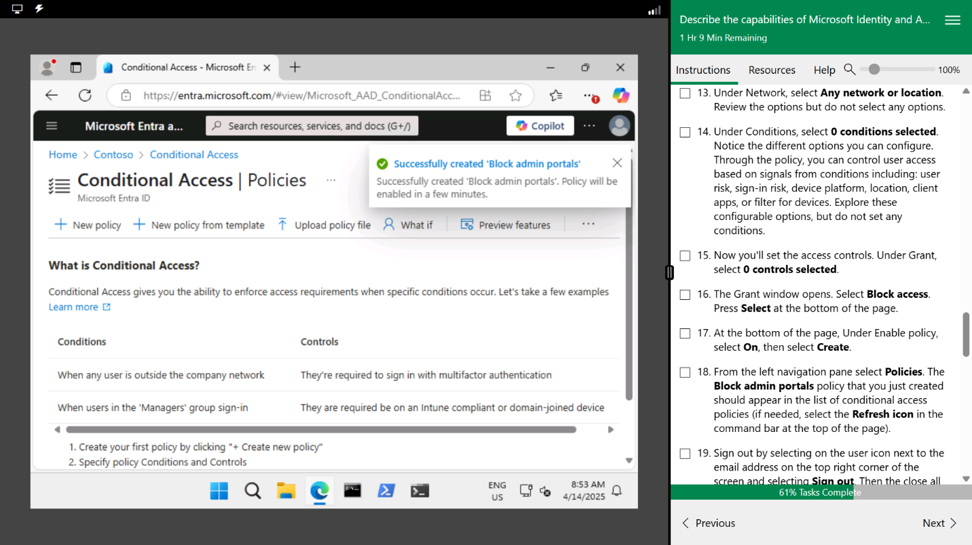

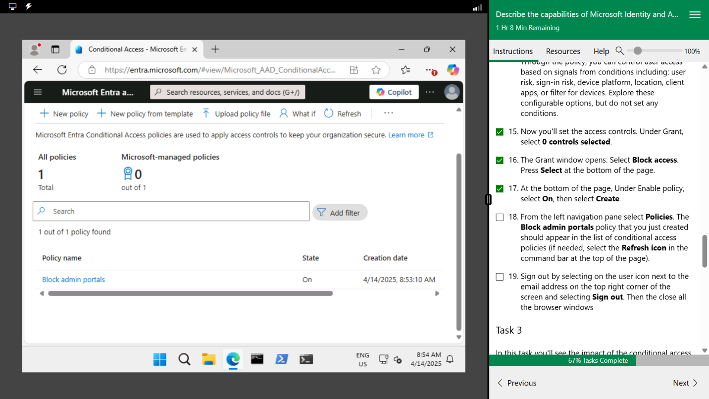

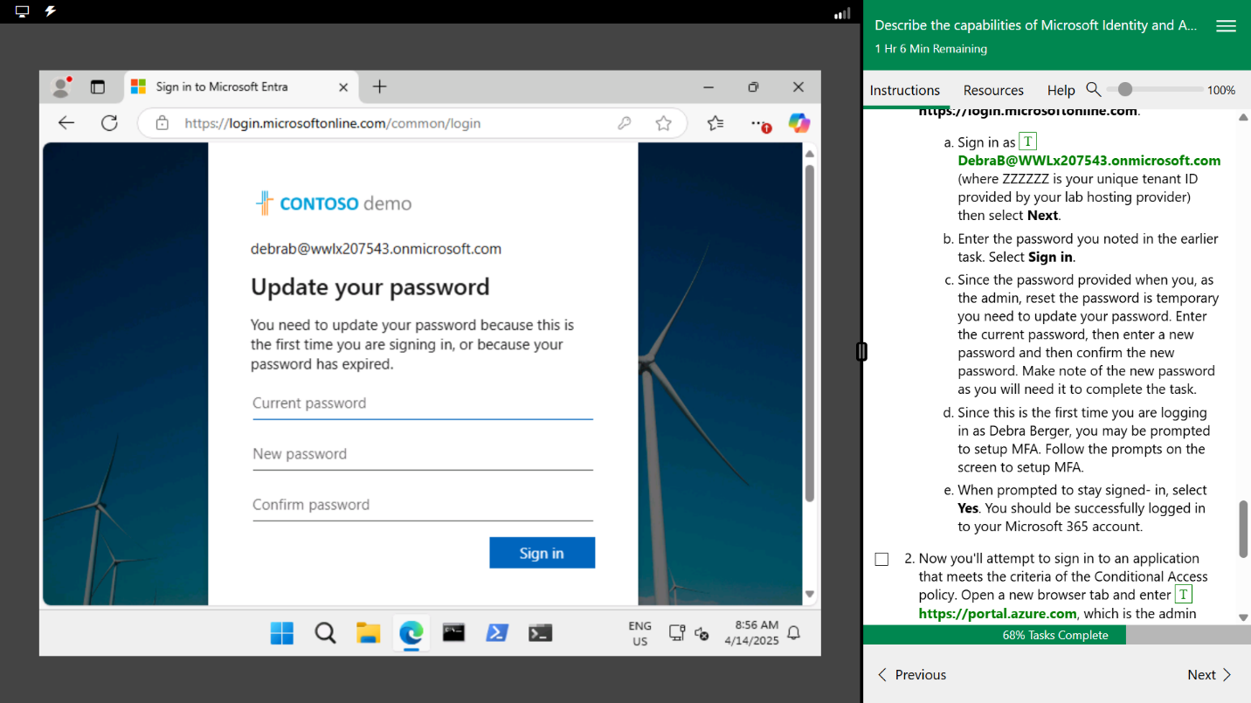

1. **EXPLORE PRIVILEGED IDENTITY MANAGEMENT.**

In this module I used a profile titled “Diego Siciliani”. I followed the instructions provided after I logged into the profile using the exact procedure from the previous module.

Here are some screenshots to show my process:

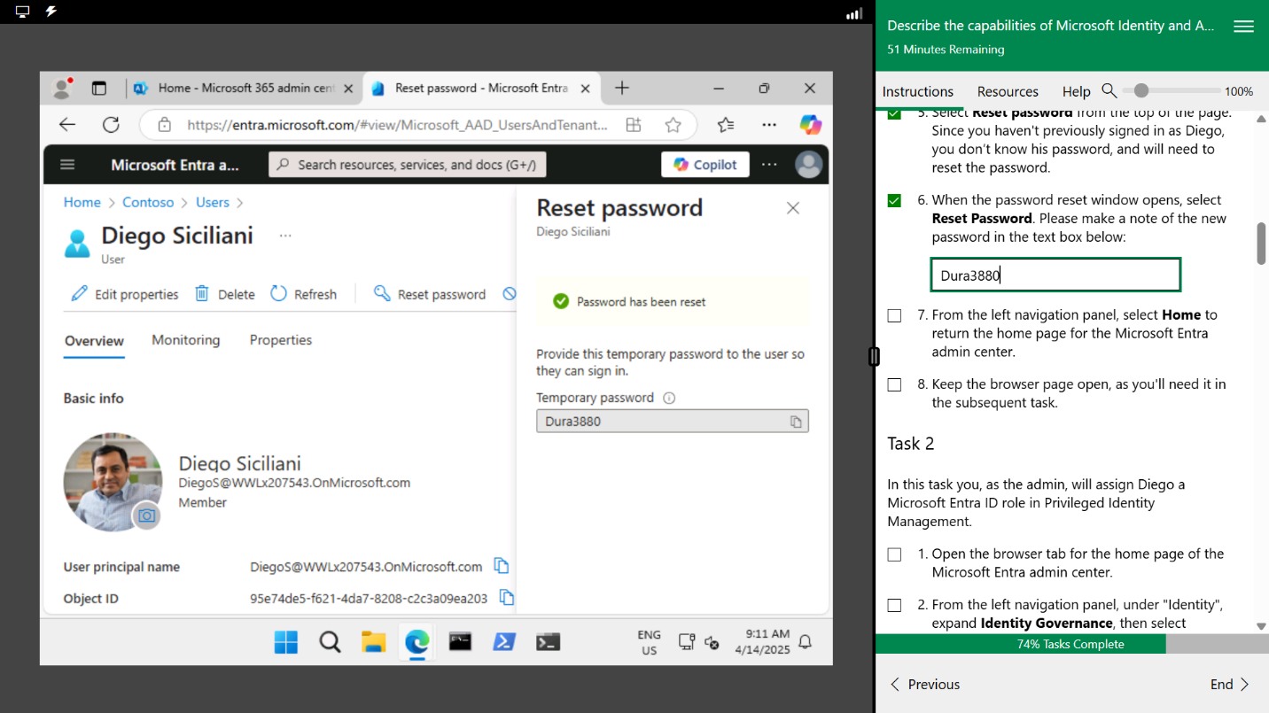

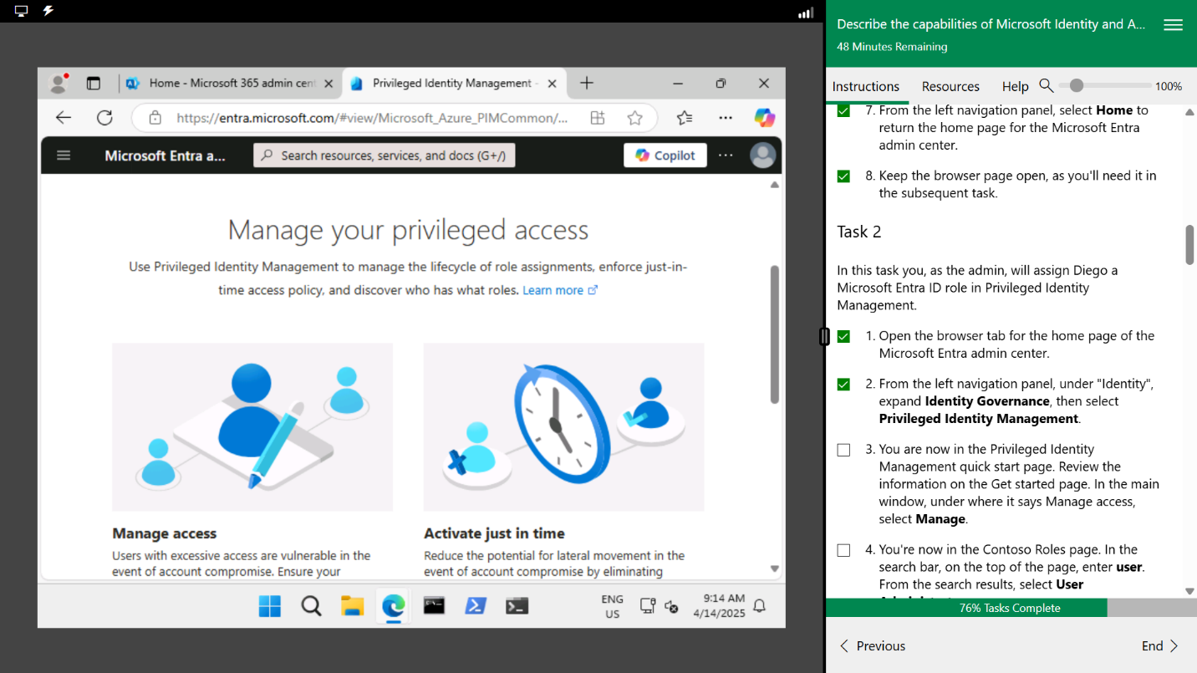

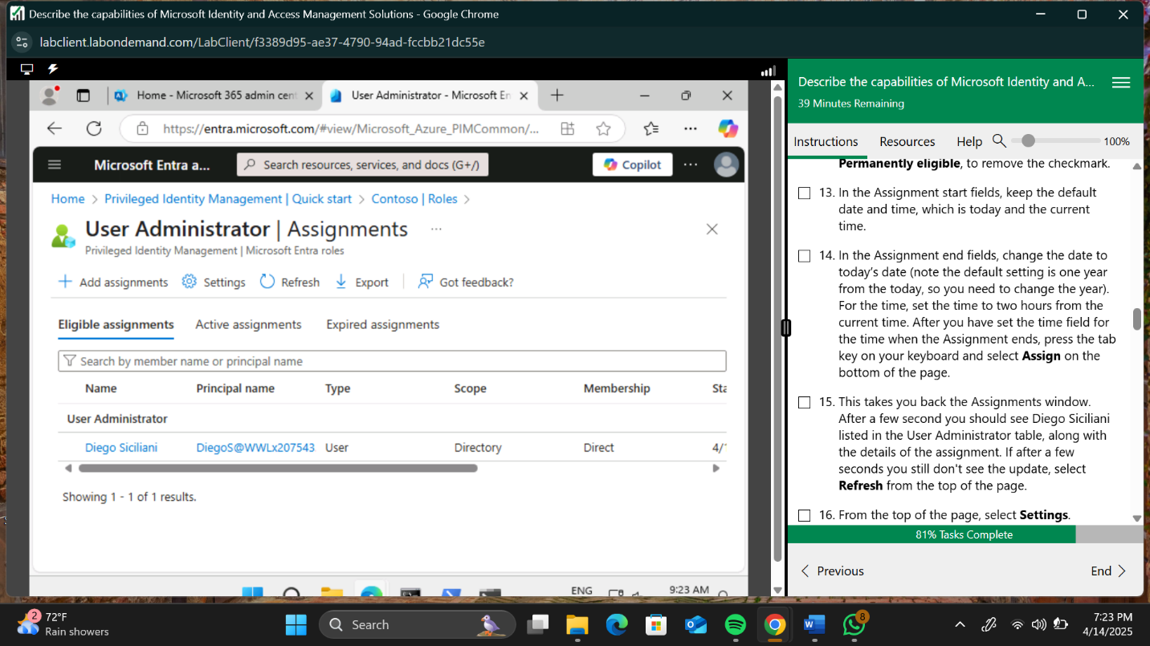

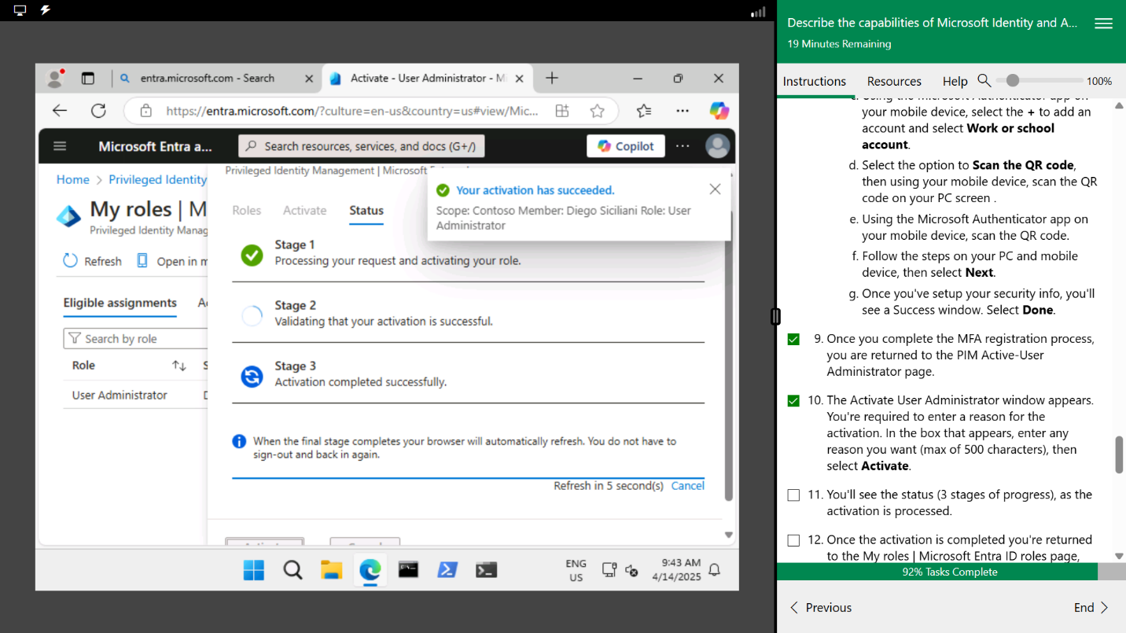

I concluded this lab by logging into and out of a profile titled “Bianca Pisani. I also got to assign her a new membership titled “Mark 8 Project Team”.

Here are the screenshots:

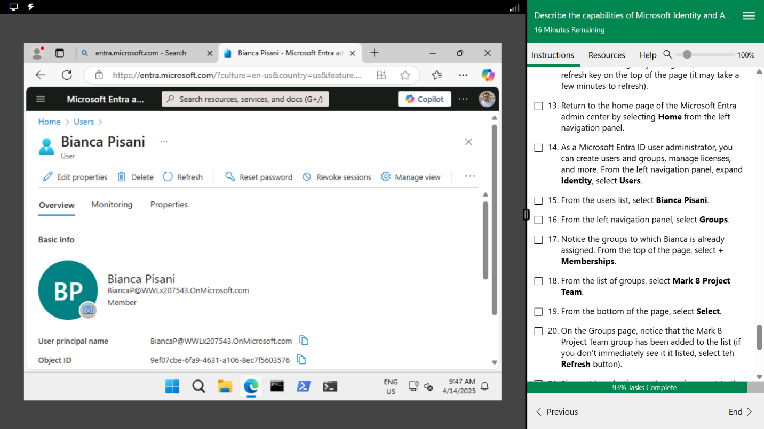

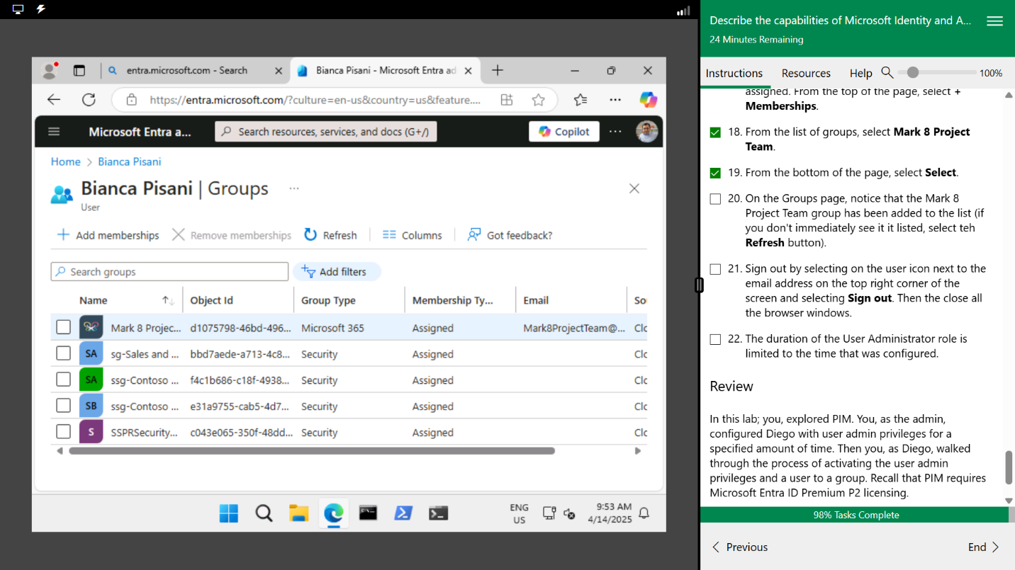

**CONCLUSION**

It took me three attempts to complete this lab activity; my first attempt was during class and the other two were personal. Considering this is a new concept to me, I am quite proud of what I achieved. Now that I’m familiar with the platform I’m sure the next lab will be a bit smoother.

I got to witness the practical aspect of the capabilities described in my resources; it serves me better to apply the aspects I spend my time learning about.